Machine-Learning
Problem Identification Assignments
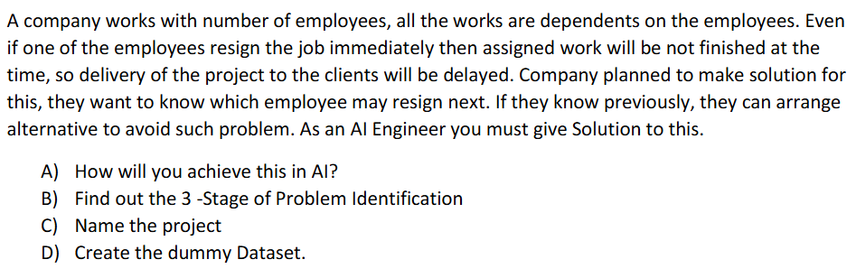

1.How will you achieve this in AI?
The assessment will be based on the employee's number of projects completed in a week, project success rate, project delivery on time, working hours per day, and number of leaves in a week.
2.Find out the 3 -Stage of Problem Identification
Problem statement: To predict employee resignation in advance.
Stage 1: Dataset type numbers – Machine Learning or Deep learning.
Stage 2: Labelled dataset – Supervised.
Stage 3: Categorical value – Employee will resign or Employee won’t resign – Classification.
3.Name of the project: Employee Resignation Prediction.
4.Create the dummy Dataset.
Input |  |  |  |  | Output
Number of projects completed in a week | Project success rate | Project delivery on time | Working hours per day | Number of leaves in a week | Label
2 | 2 | 2 | 8 | 0 | Not resigned
3 | 1 | 2 | 7 | 1 | Not resigned
1 | 0 | 0 | 12 | 2 | Resigned

